Class Design

# Create Initial Design Classes

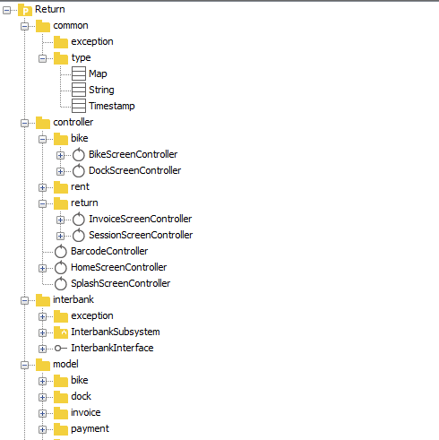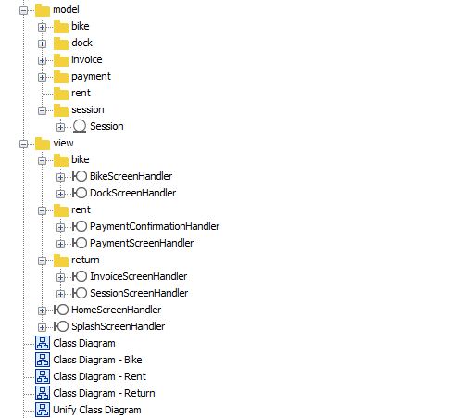

# Define Relationships Between Classes

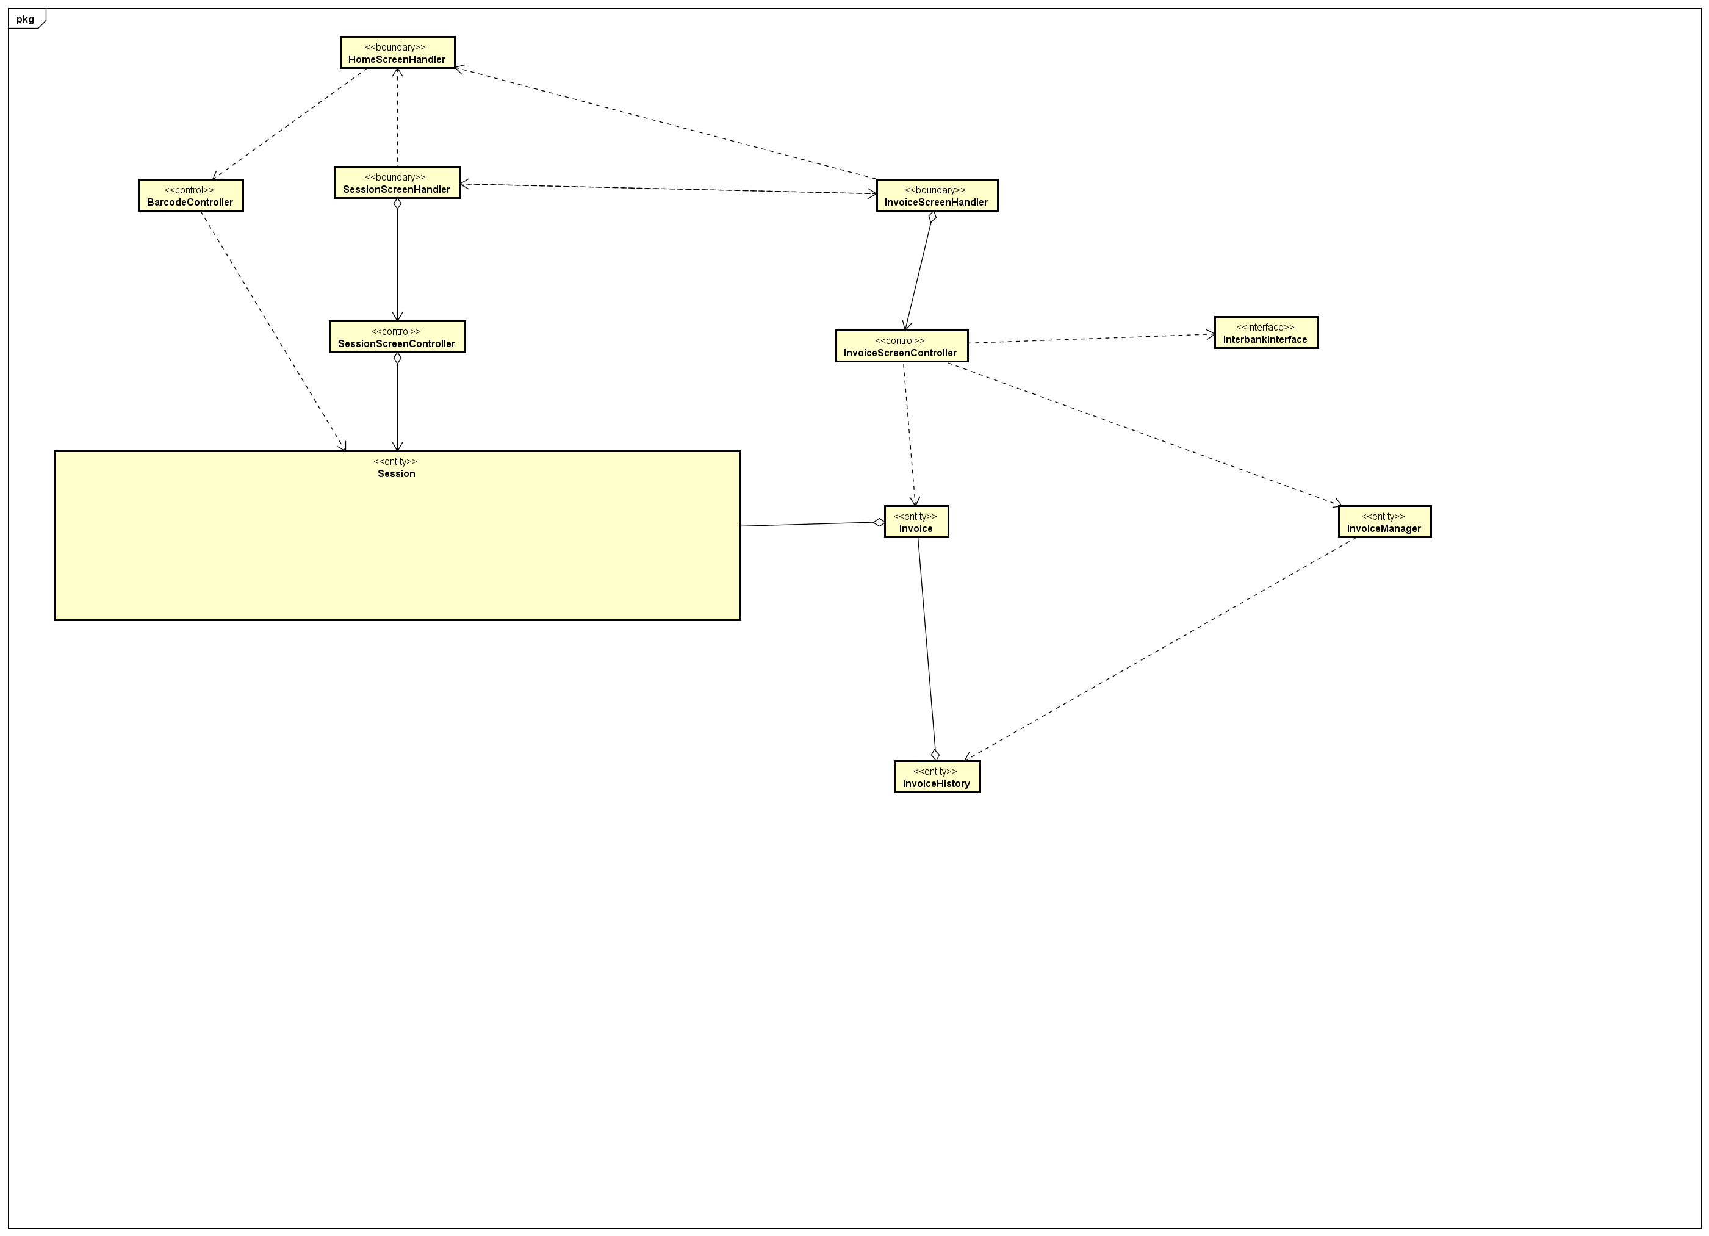

# Class Design

## Class “SessionScreenHandler”

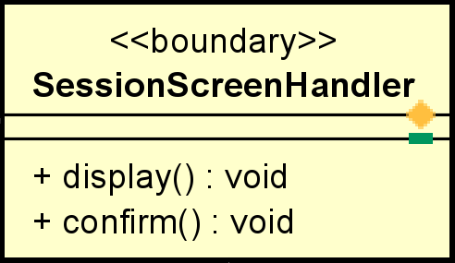

**Attribute**

None

**Operation**

|  |  |  |  |
| --- | --- | --- | --- |
| # | Name | Return type | Desciption |
| 1 | display | void | Display renting session |
| 2 | confirm | void | Handler for user to move to invoice screen |

Parameter:

None

Exception:

None

**Method**

None

**State**

None

## Class “SessionScreenController”

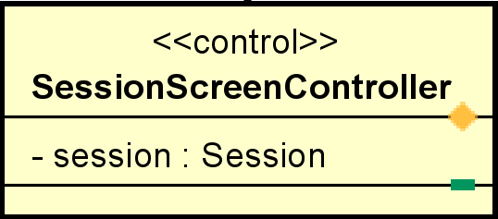

**Attribute**

|  |  |  |  |  |
| --- | --- | --- | --- | --- |
| # | Name | Data type | Default value | Description |
| 1 | session | Session | NULL | Renting Session |

**Operation**

None

Parameter:

None

Exception:

None

**Method**

None

**State**

None

## Class “Session”

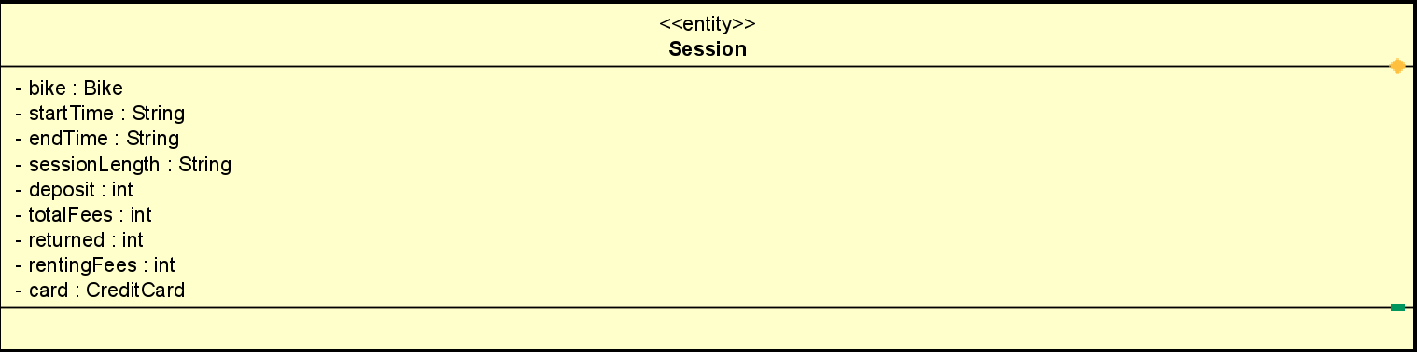

**Attribute**

|  |  |  |  |  |
| --- | --- | --- | --- | --- |
| # | Name | Data type | Default value | Description |
| 1 | bike | Bike | NULL | Bike info |
| 2 | startTime | String | NULL | Renting start time |
| 3 | endTime | String | NULL | Renting end time |
| 4 | sessionLength | String | NULL | Renting length time |
| 5 | totalFees | int | 0 | total price |
| 6 | deposit | int | 0 | deposit |
| 7 | returned | Int | 0 | Returned money |
| 8 | rentingFees | int | 0 | Renting Fee |
| 9 | card | CreditCard | NULL | Credit card info |

**Operation**

none

Parameter:

none

Exception:

None

**Method**

None

**State**

None

## Class “InvoiceScreenHandler”

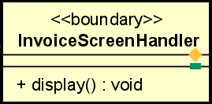

**Attribute**

None

**Operation**

|  |  |  |  |
| --- | --- | --- | --- |
| # | Name | Return type | Desciption |
| 1 | display | void | Display invoice |

Parameter:

None

Exception:

InternalServerErrorException

**Method**

None

**State**

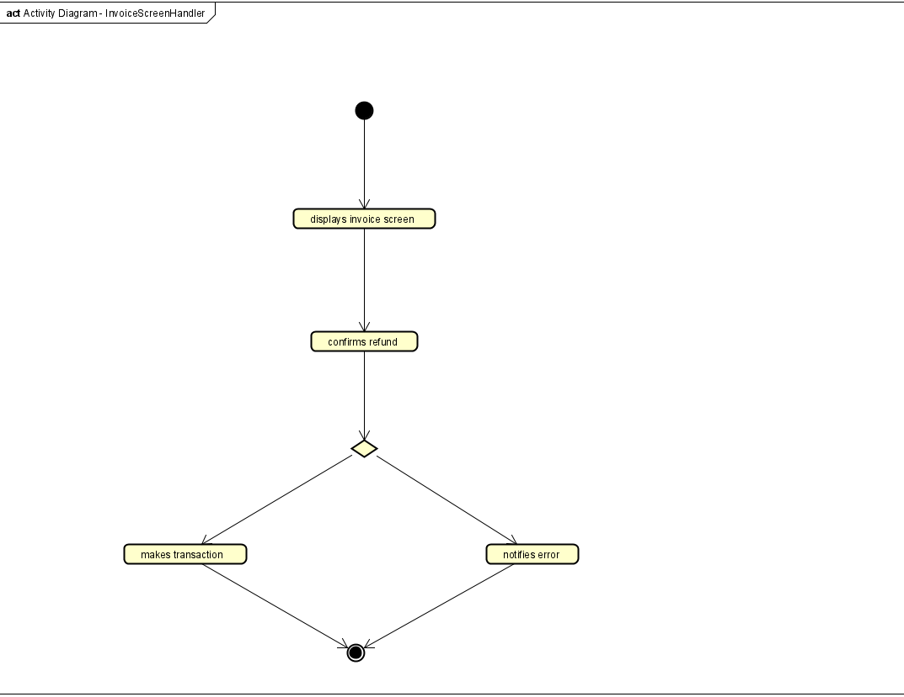

## Class “InvoiceScreenController”

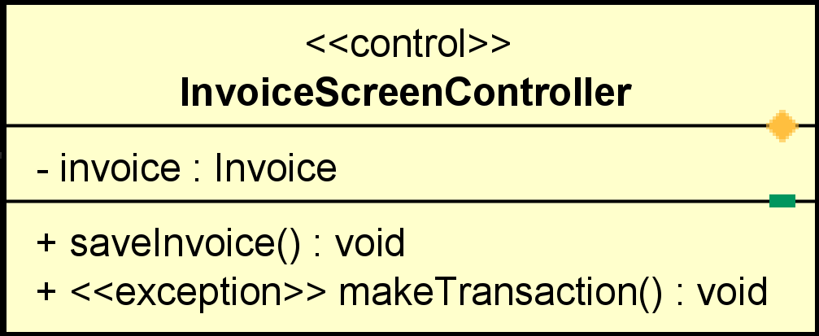

**Attribute**

|  |  |  |  |  |
| --- | --- | --- | --- | --- |
| # | Name | Data type | Default value | Description |
| 1 | invoice | Invoice | NULL | Invoice info |

**Operation**

|  |  |  |  |
| --- | --- | --- | --- |
| # | Name | Return type | Desciption |
| 1 | saveInvoice | void | Save invoice history |
| 2 | makeTransaction | void | Make transaction |

Parameter:

None

Exception:

None

**Method**

None

**State**

None

## Class “Invoice”

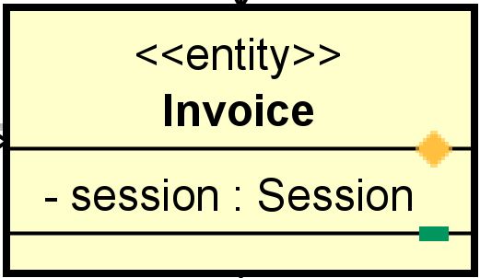

**Attribute**

|  |  |  |  |  |
| --- | --- | --- | --- | --- |
| # | Name | Data type | Default value | Description |
| 1 | session | Session | NULL | Invoice info |

**Operation**

None

Parameter:

None

Exception:

None

**Method**

None

**State**

None

## Class “InvoiceManager”

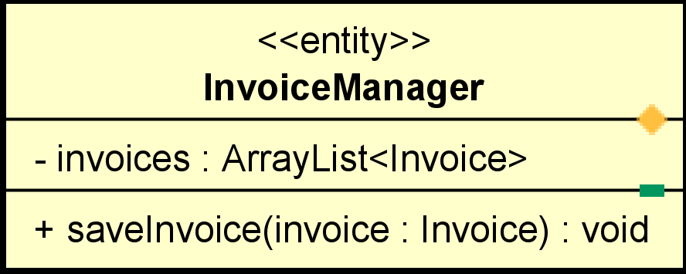

**Attribute**

|  |  |  |  |  |
| --- | --- | --- | --- | --- |
| # | Name | Data type | Default value | Description |
| 1 | invoices | ArrayList | Empty array | List invoices |

**Operation**

|  |  |  |  |
| --- | --- | --- | --- |
| # | Name | Return type | Desciption |
| 1 | saveInvoice | void | Save invoice history |

Parameter:

None

Exception:

None

**Method**

None

**State**

None

# Class Diagram

